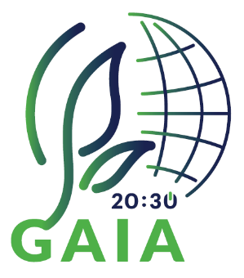

PROTECTING GLOBAL BIODIVERSITY CAMPAIGN #GAIA2030 #GenerationRestoration

GAIA 20:30 Biodiversity Sub-Goals:
- Preserving existing and creating new forests or natural areas, e.g., school gardens, parks, green neighbourhoods, etc.;
- Promoting sustainable management of the coastal zone;
- Combatting pollinator and insect loss;
- Raising awareness of and supporting actions to remove invasive alien species.

- AUTHOR DETAILS

- Name/s
- Country
- Institution/School
- Email
- Programmes the school is participating in (Eco-Schools/LEAF/YRE/other)
- Would you like to receive monthly updates through our Newsletter? Yes/No
- Submission date (dd/mm/yyyy)

- THE LESSON PLAN

- Theme – The title of the lesson

- Introduction – A brief description of what the lesson is about. (100 words max.)

- Age Group – Age group that it is suitable for (e.g. Age 6 to 9, Age 10 to 11, etc.)

- Objectives or Learning Outcomes – List 3-5 objectives/learning outcomes that you are expecting to achieve during the lesson.

- Time required to deliver the lesson plan – If more than one class session (30-45mins), please indicate the time required.

- Remote preparation - (if any) Anything that you (or the students) need to do BEFORE the lesson. (e.g. collect and bring to school 3 items of plastic that could offer a threat to wildlife)

- Planning considerations - (if any) such as (i) ‘warnings’ about misconceptions students might have about the lesson’s topic and how to deal with them; (ii) safety precautions; (iii) tips and other useful information

- Resources Required to deliver the lesson plan – Material, equipment and reading resources needed

- Activity – Steps or description of how the lesson will be conducted/facilitated by the teacher. Structure your description using these main headings:
  - Introduction

  - Development

  - Conclusion

- Evaluation and Assessment – How will you check that the Objectives or Learning Outcomes (listed in D) were achieved?

- Dissemination – How will you communicate about the products of the lesson for awareness raising? If your lesson plan has already been implemented, attach a link of a product produced during the lesson (e.g., video, poster, presentation, URL link/website link).

- Follow-up activity - (if any) Suggest an activity that can build on what the students learned during your lesson

- Adaptations for students with learning difficulties – (if any)

- Extension for gifted students – (if any)

- Background information for teachers - Include any website links and resources that would provide teachers with useful information about the lesson’s topic

- References – Acknowledge the resources that were used while developing the Lesson Plan.

